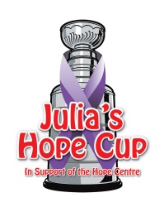
Julia’s Hope Cup 2020 PLEDGE SHEET

Dear Sir or Madam,
Thank you for your pledge to help _______________________ participate in this year’s Julia’s Hope Cup. Your pledge contributes to the cost to enter the Julia’s Hope Cup hockey tournament on Feb 15th, 2020.
All donations received go directly to support the Hope Centre.

Thank you very much for your support.

NAME | ADDRESS | AMOUNT

The Hope Centre 570 King St, Welland, ON L3B 3L2 Phone: 905-788-0748 Fax: 905-788-0748
Email: info@thehopecentre.net Web: www.thehopecentre.net Charitable Registration No. 11929 0591 RT0001

